1:1 Provide background information on the project including reason and objectives of the site investigations, the site selection process and any proposals for future works at the site.
The Irish Wave Energy Developers Association (IWEDA) is a not for profit limited company which was formed by 11 Irish Wave Energy developers to promote the interests of the wave energy industry in Ireland. The members are all early stage developers between concept and ¼ scale.
IWEDA members believe that there is a gap in the wave energy test facilities and there is a need for a benign ocean test site in Ireland at around 1/15 scale. At present developers are expected to go from tank testing at the Beaufort to the Galway test site. There is a huge financial risk involved in moving from a tank test model to deploying a device in an ocean environment where it could be hit by waves of up to 8m. The costs involved for site rental, moorings, deployment monitoring and recovery could be anywhere from €500,000 to €2 million. . Developers and their investors have been reluctant to take this leap of faith
Testing at the 1:15 scale reduces the cost to developer and the state. It is a major saving to discover at 1:15 scale rather than at 1:4 scale that a device has underlying issues not evident in tank tests and that reassessment is needed. The step between large scale wave tank testing at 1:15 and offshore 1:4 scale device performance is big and costly. A 1/15 site would complement existing infrastructure in Ireland and so would accelerate wave energy development. Progress to the Galway Bay 1:4 scale test site would be more rapid and more effective. This extra stepping stone would assist developers to attract investment for the significantly higher costs of the move to 1:4 scale.

With this in mind IWEDA set about looking for a suitable site. An area in Blacksod bay was identified (see map below). The location has a lot of advantages. There is a pier within 900m. The pier has a 1 ton crane and a slip way for launching devices. The site itself has a sandy bottom sloping from 8m LWS to 14m LWS. There are work boats and divers in the area to carry out deployment and recovery. The project enjoys the support of the local fishermen, the local community and Mayo County Council.

To make a final decision on the suitability of the site for testing wave devices we would need to characterise the prevailing wave climate. To do this we are proposing the deployment of a Datawell Wave rider Buoy at the site.

1:4 Survey methodologies and equipment to be used for each survey type proposed:
A directional wave rider buoy will be deployed within the test site for data collection. The buoy will be deployed from a half-Decker. This device will be Directional Waverider DWR-G. 0.7 m diameter, AISI316 hull, It will be painted yellow, and IALA regulation compliant. It will float on the surface and be connected to a weight on the seafloor of c. 500kg with a footprint of 5m².

The buoy will be placed in the center of the test area outlined in red on the map below at coordinates
- Latitude - 54 : 06.4
- Longitude - 10 : 03.2
Data from the buoy will be sent by HF transmitter to a shore based receiver located in the civic offices in Belmullet. The data will be transmitted at a frequency range 25.5 MHz - 35.5 MHz. This frequency was chosen so as not interfere with other data collection buoys which have been deployed in the area.

Wave rider buoy
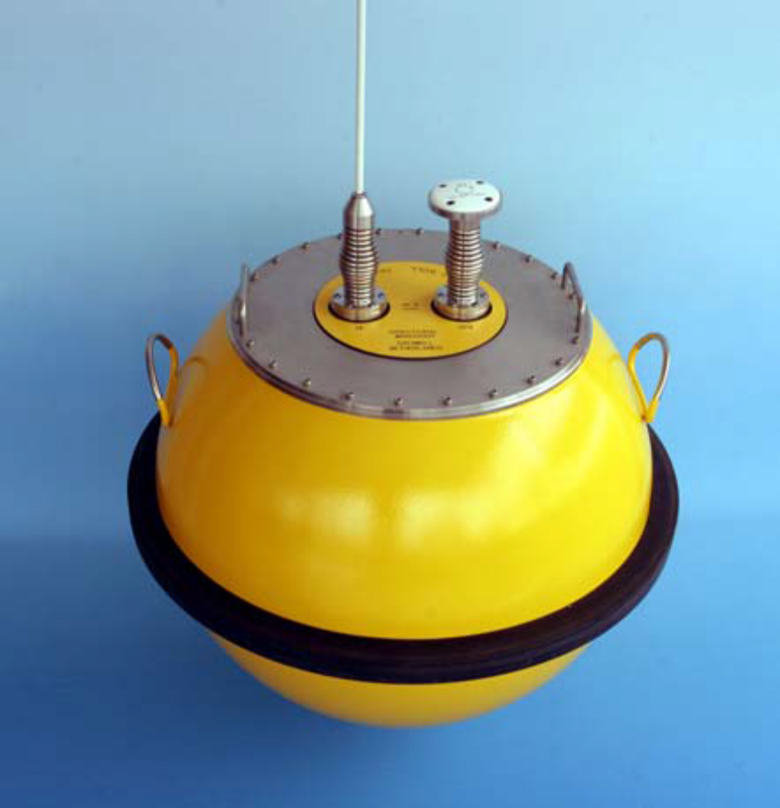
Figure 1

1:6 Provide information on proposed mooring, marking and lighting arrangements for any proposed deployment of instrument arrays.
The boy will be attached to 2x 15m rubber cord 27 mm diameter. This will be attached to a chain and anchor on the sea floor. Weight approximately 500Kg. The mooring depth is 10m LWS.
The buoy is painted bright yellow as per picture above, An LED flashing light if fitted to the top of the antenna for night time visibility. The light consists of 4 high intensity LEDs, colour yellow (590 nm). The sequence is 5 flashes every 20 s

Map of proposed test site
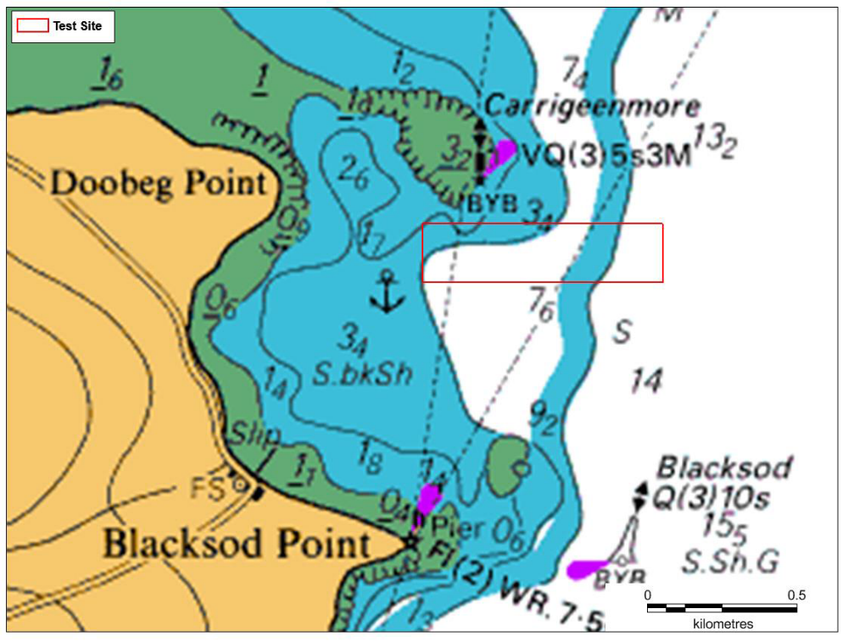
Coordinates of proposed test site.
Longitude | Latitude | Easting | Northing
-10.0597 | 54.10825 | 65337.24 | 319641.7
-10.0597 | 54.10647 | 65331.59 | 319443.2
-10.0474 | 54.10646 | 66136.43 | 319419
-10.0474 | 54.10824 | 66141.9 | 319617.4

.

.

